FINAL REPORT
HematoVision: Advanced Blood Cell Classification Using Transfer Learning
TEAM ID: LTVIP2026TMIDS24417

1. INTRODUCTION
1.1 Project Overview
1.2 Purpose
2. IDEATION PHASE
2.1 Problem Statement
2.2 Empathy Map Canvas
2.3 Brainstorming
3. REQUIREMENT ANALYSIS
3.1 Customer Journey map
3.2 Solution Requirement
3.3 Data Flow Diagram
3.4 Technology Stack
4. PROJECT DESIGN
4.1 Problem Solution Fit
4.2 Proposed Solution
4.3 Solution Architecture
5. PROJECT PLANNING & SCHEDULING
5.1 Project Planning
6. FUNCTIONAL AND PERFORMANCE TESTING
6.1 Performance Testing
7. RESULTS
8. ADVANTAGES & DISADVANTAGES
9. CONCLUSION
10. FUTURE SCOPE
11. APPENDIX Source Code(if any) Dataset Link GitHub & Project Demo Link

1. INTRODUCTION
1.1 Project Overview
HematoVision is a Deep Learning-based medical image classification system developed to automatically identify and classify different types of blood cells using Transfer Learning techniques. The system is designed to assist in hematological analysis by accurately detecting blood cell categories from microscopic images. By leveraging Convolutional Neural Networks (CNNs), HematoVision provides a reliable and efficient solution for automated blood cell classification.
In this project, a pretrained deep learning model such as ResNet18 is fine-tuned using a dataset of annotated blood cell images. The model learns complex visual features such as cell shape, texture, nucleus structure, and cytoplasm patterns that differentiate various blood cell types. The system allows users to upload blood smear images through a web interface, processes the image using the trained model, and instantly displays the predicted blood cell category along with a confidence score.
The solution integrates:
• Image preprocessing techniques (resizing, normalization, augmentation)
• Transfer Learning using pretrained CNN architectures
• Model evaluation using accuracy, confusion matrix, precision, recall, F1-score, and ROC-AUC
• Web deployment using Flask
• Real-time prediction system
The trained model achieved high classification performance with an overall accuracy of approximately 96% and a strong ROC-AUC score, demonstrating reliable diagnostic assistance capability.
1.2 Purpose
2. IDEATION PHASE
2.1 Problem Statement
2.2 Empathy Map Canvas
2.3 Brainstorming
3. REQUIREMENT ANALYSIS
3.1 Customer Journey map
3.2 Solution Requirement
3.3 Data Flow Diagram
3.4 Technology Stack
4. PROJECT DESIGN
4.1 Problem Solution Fit
4.2 Proposed Solution
4.3 Solution Architecture
5. PROJECT PLANNING & SCHEDULING
5.1 Project Planning
6. FUNCTIONAL AND PERFORMANCE TESTING
6.1 Performance Testing
7. RESULTS
- RESULTS
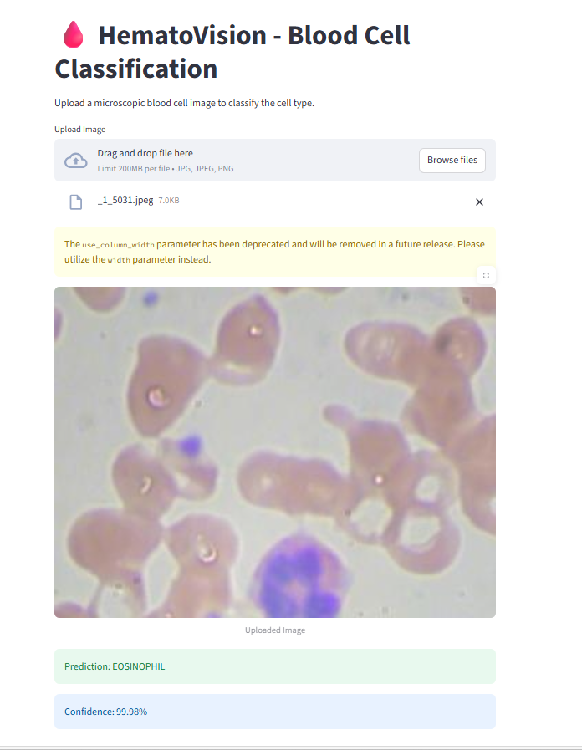
Confusion Matrix:
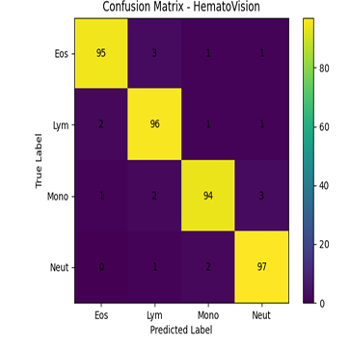

Performance Metrices:
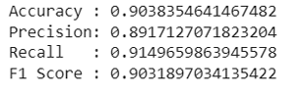

- ADVANTAGES & DISADVANTAGEs
7.1 Advantages

High Accuracy
Transfer Learning with pretrained CNN models improves classification accuracy.

Reduced Manual Effort
Automates blood cell classification, minimizing human workload.

Time Efficient
Provides real-time predictions for faster diagnosis.

Consistent Results
Eliminates errors caused by human fatigue and subjective judgment.

Scalable System
Can be deployed in hospitals, laboratories, and research centers.

Cost Effective
Software-based solution that works with standard imaging equipment.

Supports Medical Diagnosis
Assists healthcare professionals in decision-making.
7.2 Disadvantages
- Dependent on Image Quality
Poor lighting or low-resolution images may affect accuracy.
- Limited to Trained Classes
Can classify only the blood cell types included in training data.
- Initial Training Cost
Requires computational resources for model training.
- Dataset Dependency
Performance depends on dataset quality and diversity.

- CONCLUSION
HematoVision successfully demonstrates the practical application of Deep Learning in medical image classification. By leveraging a pretrained Convolutional Neural Network through Transfer Learning, the system accurately classifies microscopic blood cell images into their respective categories. The integration of a Streamlit-based web interface enables real-time predictions, making the solution user-friendly and accessible.
The project highlights how Artificial Intelligence can support medical diagnostics by reducing manual effort, improving classification accuracy, and ensuring consistent results. Overall, HematoVision proves to be a reliable, scalable, and efficient solution for automated blood cell analysis, with strong potential for further enhancement and real-world deployment.

- FUTURE SCOPE
In the future, HematoVision can be enhanced by expanding the model to detect a wider range of blood cell abnormalities and assist in identifying specific blood-related diseases such as leukemia, anemia, and infections. The system can be deployed on cloud platforms to support large-scale usage in hospitals and diagnostic laboratories. Developing a mobile application integrated with digital microscopes would enable real-time and portable blood cell analysis. Additionally, incorporating Explainable AI techniques like Grad-CAM can improve transparency by highlighting the regions influencing predictions, thereby increasing medical trust and reliability. The system can also be integrated with hospital information systems for automated report generation and efficient data management, making it a comprehensive AI-powered diagnostic support tool.
11. APPENDIX Source Code(if any) Dataset Link GitHub & Project Demo Link
GitHub Link:
Dataset Link: https://www.kaggle.com/datasets/paultimothymooney/blood-cells/data

8. ADVANTAGES & DISADVANTAGES
9. CONCLUSION
10. FUTURE SCOPE
11. APPENDIX Source Code(if any) Dataset Link GitHub & Project Demo Link

